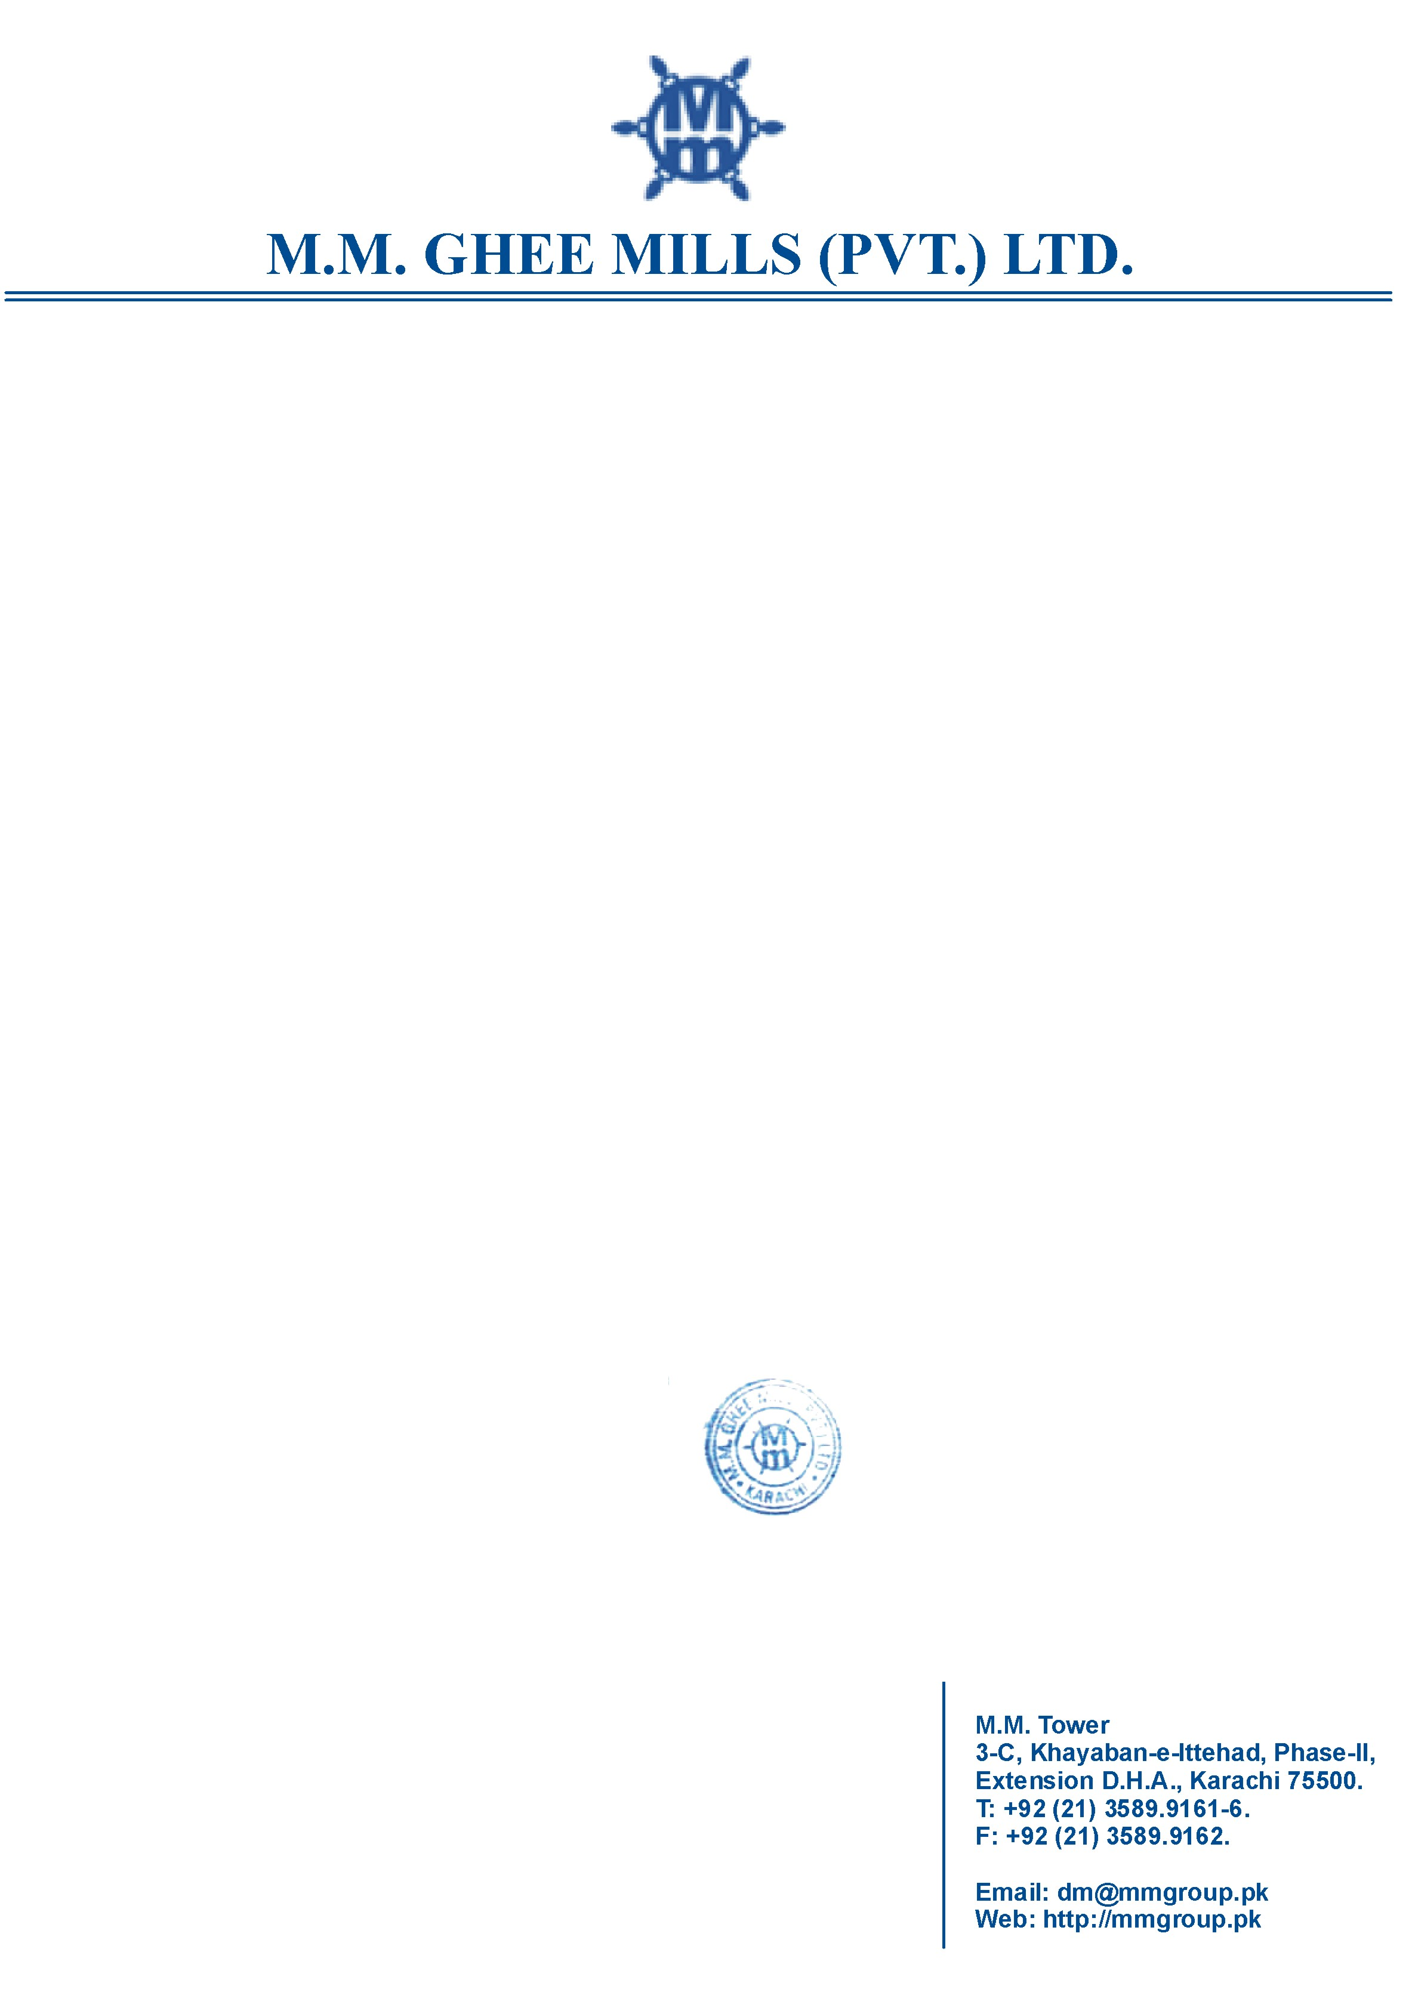

**TO WHOM IT MAY CONCERN**

This is to certify that <Name> S/O <fname> worked with M.M. Ghee Mills (Private) Limited from <From> to <To> as <Designation>.

During his service with us he was found to be hard working, well behaved, energetic, reliable and co-operative person. He has been working out of the way, for the success of the company. He has displayed a high degree of dedication to work. He was liked by his seniors, colleagues aas well as subordinates alike.

He is leaving at his own accord. This certificate has been issued without any prejudice.

For: M.M. Ghee Mills (Pvt.) Ltd.

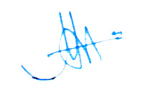

General Manager Administration

Ltd. Col M. Zafar Iqbal (Retd)

Dated: 03-Dec-2015